Aim:
The aim of this module is to give students the opportunity to carry out and report a sound empirical investigation of a research topic of personal interest to the student in pharmaceutical science.
https://www.keele.ac.uk/modcat/2017-8/psy-30061.htm

Intended Learning Outcomes (ILOs):
ILO: Group skills
On successfully completing the practical research course you will be able to...
1.Identify a research problem in a specific field(s) of pharmaceutical science. [Assessment 1,2,3,4 ,5]
2.Search the available sources to gather information and review the literature in a specific field(s). [Assessment 1,2 ,3,5]
3.Plan, design and execute the research project complying with the pharmaceutical ethical requirements. [Assessment 1,2,3]
4.Write up their research project thesis following APA report writing conventions. [Assessment 3,5]
ILO: Personal skills
On successfully completing the practical research course you will be able to...
5.Communicate effectively arguments, evidence and conclusions using written and oral means in a manner appropriate to the intended audience. [Assessment 3,4]
6.Analyze and evaluate appropriate data and complete a range of research-like tasks with limited guidance. [Assessment 1,3,5]
7.Interact with a research team and deal proficiently with the issues that teamwork requires (i.e. communication, motivation, decision-making, awareness, responsibility, and management skills, including setting and working to deadlines). [Assessment 1,2]

8.Demonstrate understanding of the professional (graduate-level) and ethical responsibilities, and commitment to them. [Assessment 1,2]
http://www.shanghairanking.com/ARWU2017.html
University of Exeter (151)

Assessment:
Assessment | Weight (%) | PIC | Due date
1. Progress report 1  2. Progress report 2 | 15  15 | Supervisor  Supervisor | End of 1st semester  End of 2nd semester
3. Poster | 20 | Poster evaluation committee | End of 1st semester
4. Oral examination  5. Thesis evaluation report | 25  25 | Examination committee  Examination committee | Week 12-14 of 2nd semester  Week 12-14 of 2nd semester
Total | 100

- progress report: a detailed report about the participation of student individually in practical and research work
- Poster: 100X100cm paper poster (the template including the basic parts will be provided)
- Oral examination: directed to evaluate the communication presentation skills and the perception of the research problem, design, methodology and results.
- Thesis evaluation report: revise the thesis according to the regulation and rules and APA style (a template will be provided)
- Poster evaluation committee: a committee of 2 members representing the five departments
- examination committee: a committee of 3 members representing the five departments

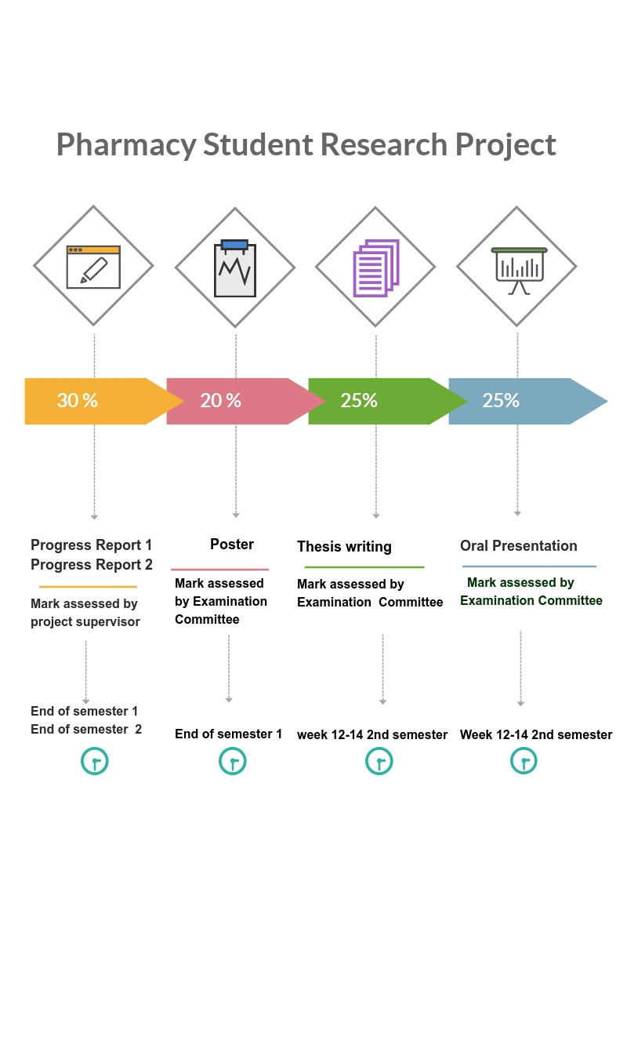

Regulations and rules for writing the thesis:
Before the oral discussion students must submit two draft copies (in plastic cover) of their thesis to the coordinators of the research project unit
The thesis must consist of not less than 25 pages including all the following parts:
- Title page (includes title, names of the student, ID, supervisor name, faculty, department,
- The title page must include the following statement “A Thesis Submitted to the B. Pharm. Program for the Course of Research Project in the College of Pharmacy”
- English abstract 250 words (one page only)
- Arabic abstract 250 words (one page only)
- Introduction
- Aim of the study
- Materials and methods
- Results and discussion
- Conclusion and recommendations
- References (APA style)
- Arabic abstract (not more than 250 words)
The thesis must be written in
- Microsoft office word,
- Paper size A4,
- Line space 1.5,
- Margins 2.5 cm in all directions
- Pages must be numbered (1,2 ….., centered, at the bottom of the pages)
- Font for Arabic part: traditional Arabic (font size 16)
- Font for English part: times New Roman (font size 14)

Note:
- Students must apply all the rules of scientific research and scientific writing particularly the assignment on the scientific literature (references),
- literal transfer of information from the source is not allowed.
- Students must make a summary of sources and display their overview. We want also to inform you that submitted thesis will subjected to plagiarism test using the software available in Umm Al-Qura University.
After the discussion (oral examination)
- Students must complete the required changes, modifications and corrections.
- The final form of the thesis must get approval from the examination committee.
- After getting the approval, students must submit three copies of their thesis in hard-cover
- The students must submit a soft copy of the following items on CD:
- The complete thesis as word file (single file, not less than 25 pages including the Arabic + English summary)
- Title page: (include the title, names of the students, faculty, in a separate word file)

For more information plz contact the PIC of Student Research Graduation Unit (SRU)
Dr. Afnan Batubara (female section)
Email:asbatubara@uqu.edu.sa

Dr. Mohammed Medhat (male section)
Email:mgamaleldin@uqu.edu.sa

