Research Project Template Instructions:
A guide to formatting your thesis

Clinical Nutrition Department
Committee of Research and Postgraduate Studies

Table of Contents
Table of Contents ii
List of Tables iii
List of Figures iv
Chapter 1. Introduction 1
1.1. About the template and instructions 1
1.2. First steps and Word settings 1
1.3. About Word styles 2
1.4. Using styles 3
1.5. Organization of thesis template styles 3
1.5.1. Paragraph and text styles 3
1.5.2. Chapter and section heading styles 4
1.6. Using the Table of Contents and lists 5
1.7. Manual formatting 5
Chapter 2. Examples 7
2.1. Font, spacing, and headings 7
2.1.1. Justification 7
2.2. Basic paragraphs and block quotations 7
2.3. Participant interviews 8
2.4. Numbered and bulleted lists 8
2.5. Poetry 9
2.6. Tables, figures, and captions 9
2.6.1. Captions 10
2.6.2. Tables 10
2.6.3. Figures 11
2.6.4. Other lists 12
2.7. Equations 12
2.8. Footnotes and endnotes 13
2.9. Reference list or bibliography 13
2.10. Landscape pages 14
Appendix A. Appendix formatting 15
Appendix B. Image file information 16
Appendix C. Customizing styles 17

List of Tables
Table 1.1. List of text styles 3
Table 1.2. List of UQU_CLINICAL NUTRITION DEPARTMENT heading styles 5
Table 1.3. Manual formatting applied to preliminary pages 6
Table 2.1 Elements of a table 9
Table 2.2 Elements of a figure 9
Table 2.3. A table of random data: captions are created in the default Microsoft caption style, which looks like this. 10
Table 2.4. This table caption uses the style 3_CaptionAbove: always put a [tab] before the start of caption text to create a hanging indent and flush left margin 10

List of Figures
Figure 1.1. Click to show nonprinting characters 1
Figure 1.2. Click to open the Styles Pane 2
Figure 1.3. Check to open the Navigation Pane 2
Figure 2.1. Insert>Caption defaults to the MS caption style for all caption labels (table, figure, scheme, etc.). 11
Figure 2.2. After creating the inserted caption, apply 3_CaptionBelow or 3_CaptionBelow_withNote to the paragraph. 12

Introduction

About the template and instructions
- The template contains Word styles to assist with formatting
- Headings, figures, tables, and captions can be numbered automatically
- The Table of Contents, List of Tables, and List of Figures are populated and paginated automatically

First steps and Word settings
The following viewing options are recommended for best use of the template, as well as this guide:
On the Home ribbon, click the ¶ button to show nonprinting characters.
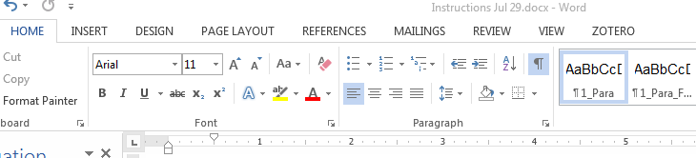
Figure ‎1.1. Click to show nonprinting characters
Also on the Home ribbon, click the button at the bottom right of the Styles menu to open the Styles pane, a full list of all the available styles in the document.
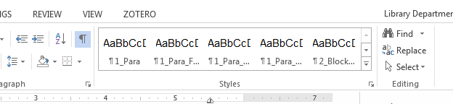
Figure ‎1.2. Click to open the Styles Pane
On the View ribbon, check Navigation Pane to display all document headings in a sidebar. For Mac users with Word 2011, the menu path is View > Sidebar > check Document Map Pane.
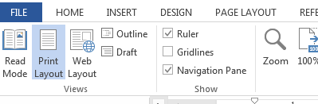
Figure ‎1.3. Check to open the Navigation Pane

About Word styles
A Word style is a saved setting that determines font, type size, line spacing, and other attributes. In the thesis template, a style always applies to a whole paragraph.
Any change made from the Font or Paragraph menu can be saved as a style. This saves time and effort over formatting manually, e.g., applying italics to each figure caption in the document. Styles ensure consistency throughout the document and allow for quick, global changes to document elements.
You must use heading styles to create automatic numbering for chapters and sections, and to populate the Table of Contents.
The active style in a paragraph is highlighted on the list in the Styles pane. Mac and Word 2016 also display the active style in a window at the top of the Styles pane. You can click on examples in this guide and consult the Styles pane to see which styles are being used.

Using styles
To apply a style, place the cursor anywhere in a paragraph and then click on a style on the style pane.
You can also select multiple paragraphs or pages and apply a style to the entire selected area.

Organization of article template styles
The template contains styles created by Clinical Nutrition Department for graduation research preparation. It also contains Microsoft default styles.

Chapter and section heading styles
UQU_CLINICAL NUTRITION DEPARTMENT heading style names do not have numbered prefixes. Headings should be used in descending hierarchical order.
The template includes one style for heading. Use of numbering is optional: consult your supervisor or a liaison librarian to determine the best practice for your discipline or your research.

Using the Table of Contents and lists
To update the Table of Contents, List of Tables, or List of Figures:
1. (Windows) Right-click anywhere in the table to open the field menu.
(Mac) Ctrl+click anywhere in the list to open the field menu.
2. Select Update Field; if prompted, select either Update page numbers only or Update entire table.
3. The list will populate with the document headings and their page numbers.

Manual formatting
Manual formatting is appropriate for unique pages or paragraphs that do not recur in the document. The thesis template uses manual formatting for some elements on preliminary pages. Details are given below in case you have to replace or recreate these pages.
Table 1.3. Manual formatting applied to preliminary pages
Page |  | Manual formatting
Title page | Author’s name | Add bold
 | Copyright statement | Reduce font size to 10pt  Single-space paragraph
Approval | Name, Degree, Title | Add bold
Abstract | Keywords | Add bold to “Keywords”  Add 1-inch hanging indent

Font, spacing, and headings
The default font in the thesis template is Arial 11pt, using 1.5 line spacing.
Applying a numbered heading style will create automatic numbering, e.g., “Chapter 2,” “2.1,” and so on. However, you don’t need to write down chapters. Just chose the style (Heading 1)

Justification
Paragraph styles are set for left justification with a ragged right margin, as seen in this document. You change the entire document to full justification in one step by editing the Normal style: see Appendix C for instructions.

Participant interviews
The template includes two styles designed for participant interviews. is shown below:
No, when I go to sea, I go as a simple sailor, right before the mast, plumb down into the forecastle, aloft there to the royal mast-head. True, they rather order me about some, and make me jump from spar to spar, like a grasshopper in a May meadow. (Ishmael, interview 3)
Remember to check the style guide you are using and consult with your supervisor to determine how interviews should be formatted.

Numbered and bulleted lists
We recommend manually numbering or lettering lists in the document.
1. When using the style, each line entry should be in a separate paragraph as shown here.
2. For each entry, type the number or letter followed by a separator (period or colon).
3. Add a [tab] before the start of the text.
4. Then apply the style.

Tables, figures, and captions
Each figure or table in the document will have up to three elements. Each element must be in a separate paragraph, with an appropriate style applied.
Table 2.1. Elements of a table
Paragraph | Element | Style
¶ 1 | Table caption | 3_CaptionAbove
¶ 2 | Table content | 3_TableHead…  3_TableData…
¶ 3 (optional) | Note | 3_TableNote
Table 2.2. Elements of a figure
Paragraph | Element | Style
¶ 1 | Image | 3_Figure
¶ 2 | Figure caption | 3_CaptionBelow  3_CaptionBelow_withNote
¶ 3 (optional) | Note | 3_FigureNote

Captions
In order for figure and table captions to populate the lists in the preliminary pages, they must be created using the Insert Caption tool, found at References>Insert Caption.
For Mac users using Word 2011, the menu path is Insert > Caption.
Inserted captions will appear in the default Microsoft caption style.

Tables
Remember to apply a caption style to the table caption.
Table 2.3. A table of random data: inserted captions are created in the default Microsoft caption style, which looks like this.
Sample size | 1349 | Control group | 3.14159
23 | 42 | 667 | 1479
Orange | β | 3 | 3.3
Note: After creating the caption, apply the style to it.
The maximum allowed width for a table is 6 inches. It is acceptable for a table to span more than one page. Use Table Properties to repeat the header row of a table at the beginning of a new page.
Table 2.4. This table caption always put a [tab] before the start of caption text to create a hanging indent and flush left margin
No | Average | Median | Sum | Total
9 | 64 | 30 | 20 | 37
13 | 61 | 320 | 91 | 74
2 | 45 | 11 | 531 | 8
157 | 167* | 439 | 467 | 6109
44 | 679 | 187 | 732 | 416
5974 | 97549 | 621 | 5** | 6795
1576 | 4879 | 564 | 529 | 1
197 | 764 | 498 | 761 | 15
* add notes, as shown here.
** When adding more than one note, use a line break [shift-enter] at the end of each line for correct spacing.

Figures
Use the Insert > Picture menu to place an image file on the page. The maximum dimensions allowed for images are 6” wide by 9” high. Text wrapping should be set to “In line with text” (no text wrap).
Images should be sized to an equivalent print resolution of 300 pixels per inch/dots per inch. For best results, insert images as flattened .tif, .png, or high quality .jpg files.
After inserting the image and checking dimensions, remember to apply one of the styles to the image. Remember to apply a caption style to the inserted caption.
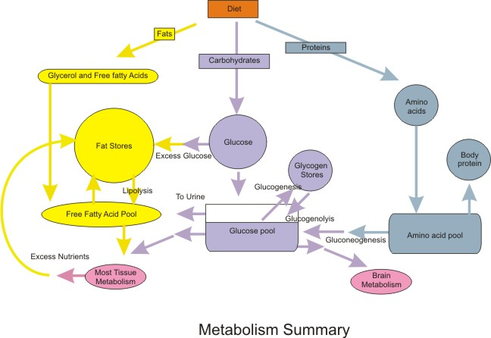
Figure ‎2.2. metabolism summary. In general metabolism may be divided into two categories: catabolism or the break down of molecules to obtain energy; and anabolism or the synthesis of all compounds needed by the cells (examples are DNA, RNA, an protein synthesis). The diagram on the left contains a summary of all the types of metabolism that will be examined. In this module, the electron transport chain is examined.
Note: If adding a note, source, or image credit, do this in a separate paragraph below the caption, as shown here and in the example below.
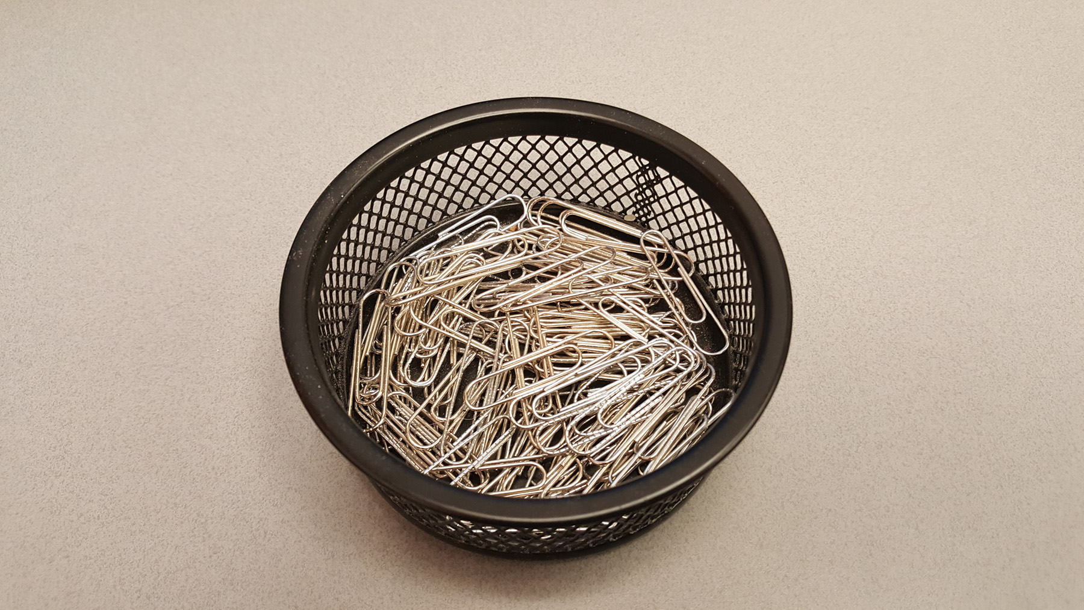
Figure ‎2.3. After creating the inserted caption to the paragraph.
Photo: Karen Eliot, Despair, 2016. Reproduced with permission.

Other lists
In the Insert>Caption menu, click on New Label to create a new category of caption label, e.g., equation, scheme, illustration.

Equations
Use Word’s default Insert>Equation tool to create equations in the document, as shown below.
$A=πr^{2}$ (1)
Word’s default font (Cambria Math) and settings are acceptable for library submission.

Footnotes and endnotes
Use the default Word settings for creating footnotes and endnotes: from the References tab, click Insert Footnote and type or paste in the note. The process is identical for endnotes. The library recommends using footnotes rather than endnotes for easier formatting and better readability.

Reference list or bibliography
Use EndNote.
Refer to Endnote pdf file
https://endnote.com/wp-content/uploads/m/pdf/en-x8-qrg-windows.pdf
For mac
https://endnote.com/wp-content/uploads/m/pdf/en-x8-qrg-mac.pdf
online library
https://endnote.com/wp-content/uploads/m/pdf/en-online-qrc.pdf
or video
https://www.youtube.com/watch?v=lnqPjjKwEPk&feature=youtu.be
the programme is available to download from the university website
https://uqu.edu.sa/lib/919

Landscape pages
Follow these two steps to ensure correct formatting and pagination of landscape pages:
1. Create the landscape section using the Custom Margins dialogue.
Select the area where you want the landscape page(s) to appear.
Windows and Word for Mac 2016: Page Layout > Custom Margins > set Orientation to landscape, set Apply to: Selected Text.
Word for Mac 2011: Select text: Layout > Margins > Custom Margins > open Page Setup and change to landscape, set Apply to: Selected Text.
2. Check the page numbering in the landscape section and set to Continue from previous section. Repeat on the first page after the landscape section. If this setting is not changed, every new section begins with a page number of 1.
Windows and Word for Mac 2016: Insert > Page Number > Format Page Numbers > Continue from Previous Section
Word for Mac 2011: Insert > Page Numbers > Format > Continue from Previous Section
These steps can also be used to create bifold (11X17) landscape pages. Legal size pages (8.5X14) are not permitted.

Important note for Mac users
When converting to PDF, Word for Mac splits the document into separate PDF files at each section break. You can use Adobe Acrobat Pro or Apple Preview to rejoin the PDFs into a single documen

For Mac users with Word 2011, the menu path is Insert>Footnote.
The thesis template uses default Microsoft styles for footnotes. It’s not necessary to apply a style after creating the note.

