**CHAPTER 2 (Font size 24)**

**GENERAL DESCRIPTION OF PROJECT COMPONENTS**

**(Font size 24)**

In this chapter we will describe general description of the components used in our project. There are two types of components: (1) Electrical components and (2) Mechanical Components

* 1. **ELECTRICAL COMPONENETS (Size 16, Bold)**

An overview of electrical components is shown in Figure. 2.1. (Size 11)



Figure 2.1: Overview of Electrical Components (Size 11)

Figure 2.1 shows that, we have used the following components

* + 1. PIC Microcontroller (Font Size 14, Bold)

Microcontrollers are integrated circuits, but they differ fundamentally from other ICs. They are a class in themselves, that the designers have not made them to do a particular job. As such when bought from the market, one can not specify what function it will do. In order to get some useful function, these ICs have to be configured or programmed [1]. (Font Size 11)

Using a configurable IC is a great idea. Not only the same IC can be configured to do different tasks, but a change in specifications can easily be implemented by just changing the device configuration. This greatly facilitated the engineers to rapidly develop new electronic devices, and continuously improve previous ones. Not only the hardware requirements decreased, but also design time was decreased. The beauty of these devices is their easy availability, low cost and easy programming and handling.

PIC microcontroller is very important part of the project that can do a lot of things such as monitoring and controlling the loads. In addition, we used PIC16F882 that manufactured by Microchip technology. Table 2.1 shows different PIC devices manufactured by Microchip technology with varying program and data memory. The microcontroller is a device that can execute the program that the user put it in its program memory.

|  |  |  |  |
| --- | --- | --- | --- |
| **Device** | **Program Memory** | **Data Memory** | |
| **Flash (words)** | **SRAM**  **(bytes)** | **EEPROM**  **(bytes)** |
| PIC16F882 | 2048 | 128 | 128 |
| PIC16F883 | 4096 | 256 | 256 |
| PIC16F884 | 4096 | 256 | 256 |

Table 2.1: PIC microcontrollers manufactured by Microchip technology

* + 1. Character LCD

LCD stands for Liquid Crystal Display. An LCD is a passive device. It does not produce any light and simply alters the light travelling through it. Most commonly used character based LCDs are based on Hitachi’s HD44780 controller or others which are compatible with HD44580 [2].

More microcontroller devices are using 'smart LCD' displays to output visual information. LCD displays designed around Hitachi's LCD HD44780 module, are inexpensive and easy to use. Hitachi LCD displays have a standard ASCII set of characters and mathematical symbols.

For an 8-bit data bus, the display requires a +5V supply plus 11 I/O lines. For a 4-bit data bus it only requires the supply lines plus seven extra lines. When the LCD display is not enabled, data lines are tri-state which means they are in a state of high impedance (as though they are disconnected) and this means they do not interfere with the operation of the microcontroller when the display is not being addressed [3].

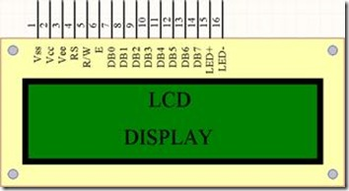

Figure 2.2: LCD

* + 1. Relay

A relay is an electrical switch that uses an electromagnet to move the switch from the Off to On position instead of a person moving the switch. It takes a relatively small amount of power to turn on a relay but the relay can control something that draws much more power.

The schematic that represent the relay shown in figure 2.3. The contacts at the top are normally open (i.e. not connected). When current is passed through the coil it creates a magnetic field that pulls the switch closed (i.e. connects the top contacts). Usually a spring will pull the switch open again once the power is removed from the coil.

A simple electromagnetic relay consists of a coil of wire surrounding a soft iron core, an iron yoke which provides a low reluctance path for magnetic flux, a movable iron armature, and one or more sets of contacts as shown in figure 2.3

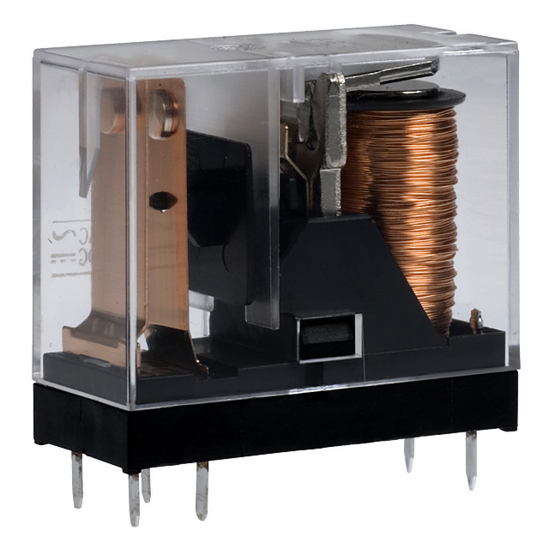

Figure 2.3: A small electrical relay.

* + - 1. Types of Relays

Relays can be categorized according to the magnetic system and operation.

* + - * 1. Neutral Relays

This is the most elementary type of relay. The neutral relays have a magnetic coil, which operates the relay at a specified current, regardless of the polarity of the voltage applied.

* + - * 1. Biased Relays

Biased relays have a permanent magnet above the armature. The relay operates if the current through the coil winding establishes a magneto-motive force that opposes the flux by the permanent magnet. If the fluxes are in the same direction, the relay will not operate, even for a greater current through the coil.

* + - * 1. Polarized Relays

Like the biased relays, the polarized relays operate only when the current through the coil in one direction. But there the principle is different. The relay coil has a diode connected in series with it. This blocks the current in the reverse direction.

The major difference between biased relays and polarized relays is that the former allows the current to pass through in the reverse direction, but does the not operate the relay and the later blocks the current in reverse direction.

* + 1. Transistors

A transistor is a semiconductor device used to amplify and switch electronic signals and electrical power. It is composed of semiconductor material with at least three terminals for connection to an external circuit. A voltage or current applied to one pair of the transistor's terminals changes the current through another pair of terminals. Because the controlled (output) power can be higher than the controlling (input) power, a transistor can amplify a signal. Today, some transistors are packaged individually, but many more are found embedded in integrated circuits.[4]

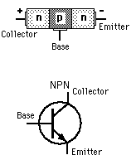

Figure 2.4: npn BJT transistor

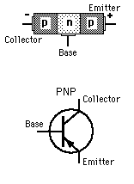

Figure 2.5: pnp BJT transistor

In addition to the above components, we have used the following electrical components.

* 1. **MECHANICAL COMPONENETS**

Machines employ power to achieve desired forces and movement (motion). A machine has a power source and actuators that generate forces and movement, and a system of mechanisms that shape the actuator input to achieve a specific application of output forces and movement. Modern machines often include computers and sensors that monitor performance and plan movement, and are called mechanical systems. Table 2.2 illustrates different type of mechanical components and their description.

|  |  |
| --- | --- |
| **Mechanical components** | **Description** |
| Structural components | These components comprise of bearings, axles, splines, fasteners, seals, and lubricants. |
| Mechanisms | It controls movement in various ways such as gear trains, belt or chain drives, linkages, cam and follower systems, including brakes and clutches. |
| Control components | Buttons, switches, indicators, sensors, actuators and computer controllers fall in this category. |

Table 2.2: Description of mechanical components

* 1. **CONCLUSION**

Devices which carry out electrical operations by using moving parts are known as electromechanical. Strictly speaking, a manually operated switch is an electromechanical component, but the term is usually understood to refer to devices such as relays, which allow a voltage or current to control other, isolated voltages and currents by mechanically switching sets of contacts, solenoids, by which a voltage can actuate a moving linkage, vibrators, which convert DC to AC with vibrating sets of contacts, etc. Before the development of modern electronics, electromechanical devices were widely used in complicated systems subsystems, including electric typewriters, teletypes, very early television systems, and the very early electromechanical digital computers.

**Appendix References**

[1] Ermann, M. D., Williams, M. B., & Shauf, M. S. (Eds.). (1997). Microcontrollers in depth. New York, NY: Oxford University Press.

[2] Odell, L., Vacca, R., Hobbs, R., & Irvin, J.L. (2001). LCD and Modern World. Austin, TX: Holt, Rinehart and Winston.

[3] Sternberg, E. (2000). Just business: Electrical devices and their usage (2nd ed.). New York, NY: Oxford University Press.

[4] Utah Association of Counties. (1981). Semiconductors and Devices. Salt Lake City: Utah Association of Counties.