Application Driven Basic Research: An Urgent Need

Samir Kumar Pal
Department of Chemical, Bilogical&MacromolecularScicences,
S. N. Bose National Centre for Basic Sciences, Salt Lake City,
Kolkata 700 106, India, Email: skpal@bose.res.in

Abstract
Country’s self reliance (independence) is the heart of any successful national science and technology planning. However, considerations like security, time factor, performance guarantee and costs often compel us to buy indispensable advanced technology from international market. Independence in technology does not mean that we have to essentially make everything ourselves, however, need to acquire capacity to do so when things come to a head.A nation’s development is immediately related to the independence in producing energy and all possible health care facilities. Self-reliance is also equally important when sustainable, effective linkages between the clinical and community settings become unavoidable for the improvement of patients' access to preventive and chronic care services. Our scientific research activities for the self-reliance in the renewable energy, environmental issues, healthcare technology development from the corner of instrumentation and nanomaterials (nanomedicines) would be highlighted in the proposed talk. Our contribution in correlating the interdisciplinary basic science with direct application in the field of sensing and agricultural will also be briefed. The community linkage of the indigenously developed technology would also be discussed.

References:http://www.bose.res.in/~skpal/pub.htm

Short CV

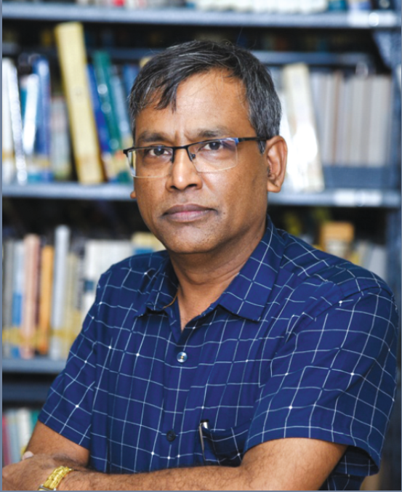

Please place your color photograph here

Full Name: Professor (Dr.) Samir Kumar Pal

Affiliation: Department of Chemical, Biological & Macromolecular Sciences, S. N. Bose National Centre for Basic Sciences, JD Block, Sector III, Salt Lake,
Kolkata (Calcutta) 700 106. India,

Education, researcher achievements, professional activity, recognition, awards:
After obtaining PhD in Physics from Indian Association of Cultivation of Science (IACS) in 2000, Dr. S. K. Pal moved to California Institute of Technology (CALTECH) to work with Professor Ahmed H. Zewail (Nobel Laureate in Chemistry 1999) till the end of 2003. Currently, Dr. S. K. Pal is a senior professor in S.N. Bose National Centre for Basic Sciences, India.

He is the recipient of Nina Saxena Excellence in Technology Award, 2019 (IIT Kharagpur), Abdul Kalam Technology Innovation National Fellowship 2018 (Indian National Academy of Engineering: INAE), P. K. Bose Memorial Award 2016 (Indian Chemical Society), UKIERI: UK-India Education and Research Initiative (Nanotechnology) Award 2007.

One of his researches is focused on Ultrafast Spectroscopy of Molecules and Materials for the potential applications in Environments, Energy and Health. He has co-authored >225 publications and 6 books, given > 250 invited presentations, and has >11000 citations, h-index of 53 and i10 index of about 198. He is also a co-inventor for more than 30 patents. Three (3) of his developed technologies have been transferred to industry and the products are in the market. Till date 25 PhD students completed their degree and 15 are enrolled under his sole supervision. He is the editors of the journal: EPJ techniques and Instrumentation (Springer, London). He is continuously serving as visiting professor in several places including CALTECH, USA, TU Brunswig, Germany, University Aarhus, Denmark, Durham University, UK, University Leiden, Netherlands e.t.c.

Selected important Publications: see http://www.bose.res.in/~skpal/pub.htm

